**Configure The Application To Receive The Data From****Cloud**

|  |  |
| --- | --- |
| Date | 17 November 2022 |
| Team Id | PNT2022TMID41953 |
| Title | Hazardous Area Monitoring for Industrial Plant using IoT |

# Node red flow created to get values

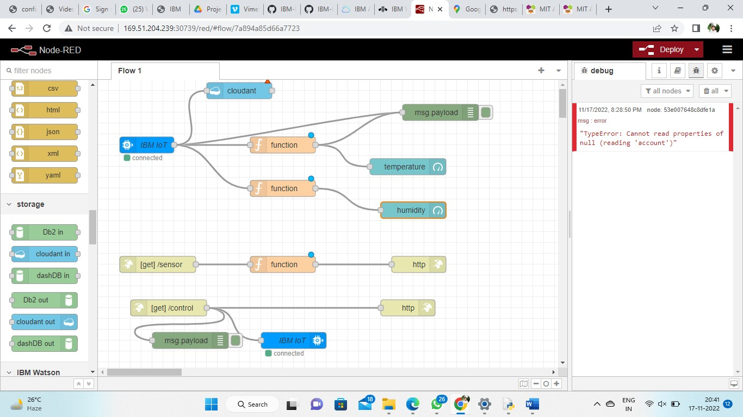

# Configuring function to fetch the desired value

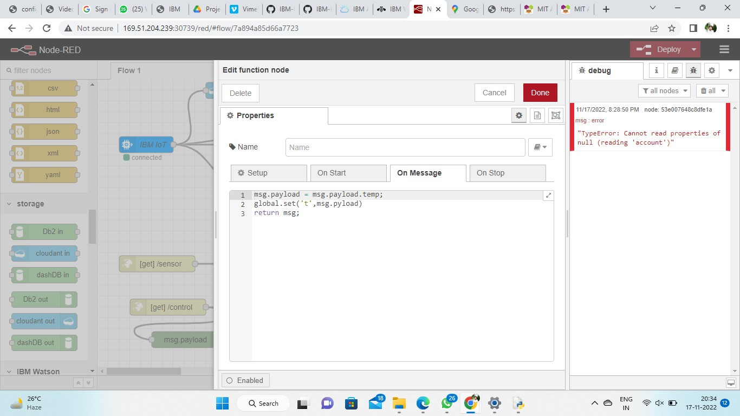

# App Blocks to render the values and display it in app

